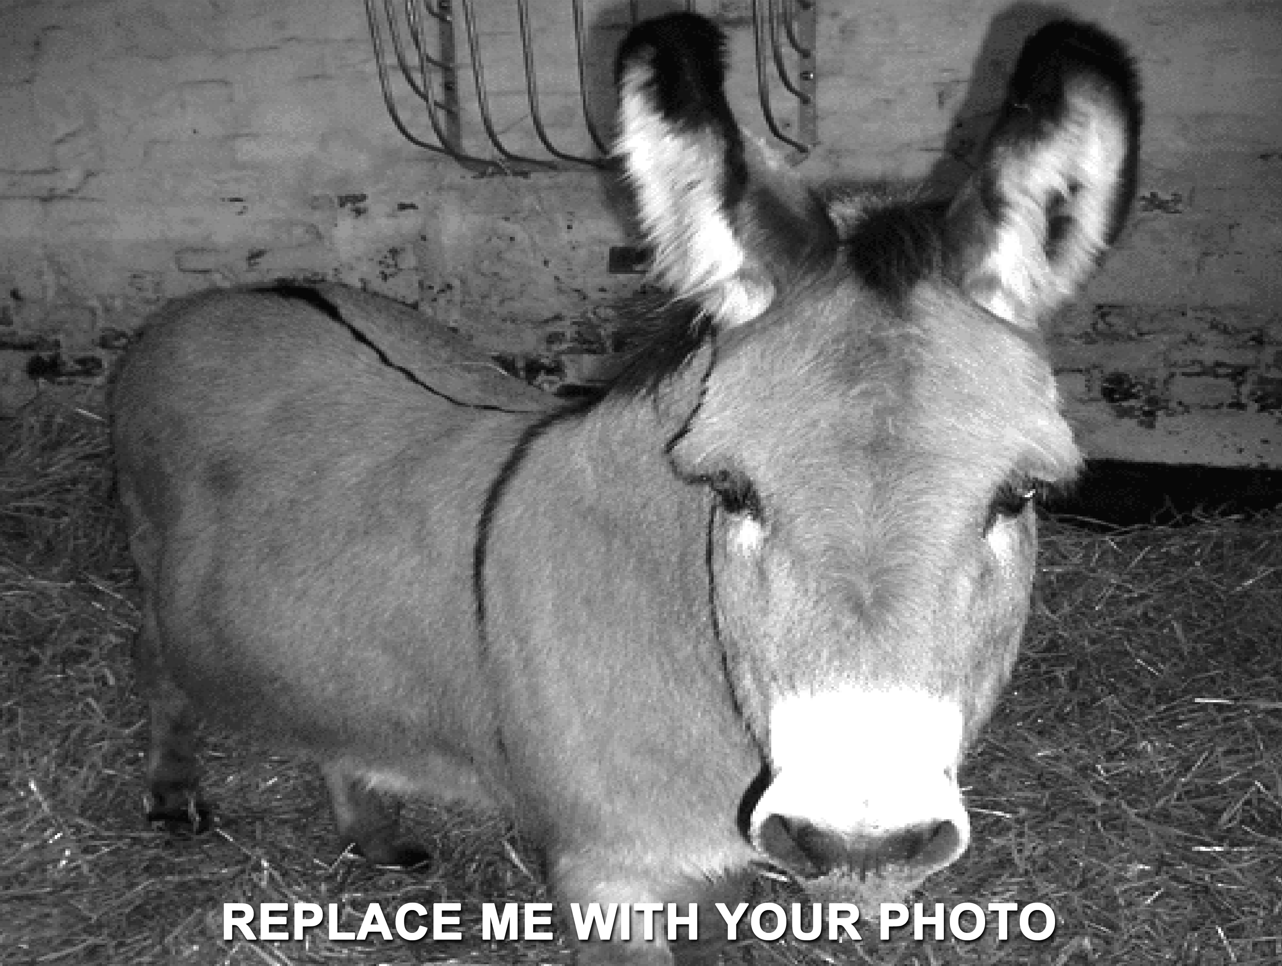

Name of Company / Employer: (Where will the forester work)

Title of Position:

Responsibilites for Position: (Brief description of what the job is like)

Job Duties:

1. One
2. Two
3. Three
4. Four
5. Five

Qualifications: What type of experience is needed for the job?

Education: How much education is needed and what is the major subject areas in college or university

Salary: how much money does the job make in a year

REWARD

WANTED!

Your copy here

WANTED NAME HERE